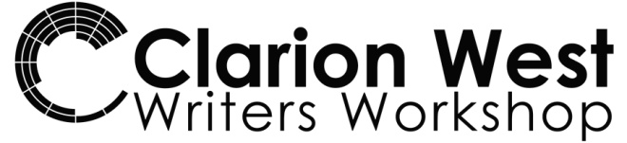
11th Annual Clarion West Write-a-thon
Please sponsor [My Name] today!
I’m writing for a good cause this summer, and I need your support.
You can sponsor me at any level—every sponsorship counts.
Go to [URL]
for information about my goals as well as how to sponsor me.
Clarion West is a nonprofit literary organization based in Seattle that is dedicated to providing high quality educational opportunities for writers of speculative fiction at the start of their careers.
Clarion West is a 501(c)(3) nonprofit organization and donations are fully tax deductible to the extent permitted by law.
clarionwest.org/writeathon/[ add your URL]
clarionwest.org/writeathon/
clarionwest.org/writeathon/
clarionwest.org/writeathon/
clarionwest.org/writeathon/
clarionwest.org/writeathon/
clarionwest.org/writeathon/
clarionwest.org/writeathon/
clarionwest.org/writeathon/
clarionwest.org/writeathon/
clarionwest.org/writeathon/
clarionwest.org/writeathon/
clarionwest.org/writeathon/
clarionwest.org/writeathon/
clarionwest.org/writeathon/
clarionwest.org/writeathon/
clarionwest.org/writeathon/
clarionwest.org/writeathon/
clarionwest.org/writeathon/
clarionwest.org/writeathon/

